Name: **ANSWERS____**____________ TIME ALLOWED: 25 min

Total marks: 28

**PART 1: RESOURCE FREE**

1. [ 1mark]

A bag of 30 lollies has 18 red ones, and the rest are black. If the first two lollies taken at random are black, what is the probability the next one will be red?

12 Black 2 taken out therefore 28 left

18/28 = 9/14

1. [5 marks: 2, 1, 1, 1]

In a certain group of 60 year 11 students, there are 35 students who study History(H), there are 45 students who study Biology (B) and there are 30 students who study both History and Biology.

1. Show this information in the Venn Diagram: ✓✓ (1/2 mark each)

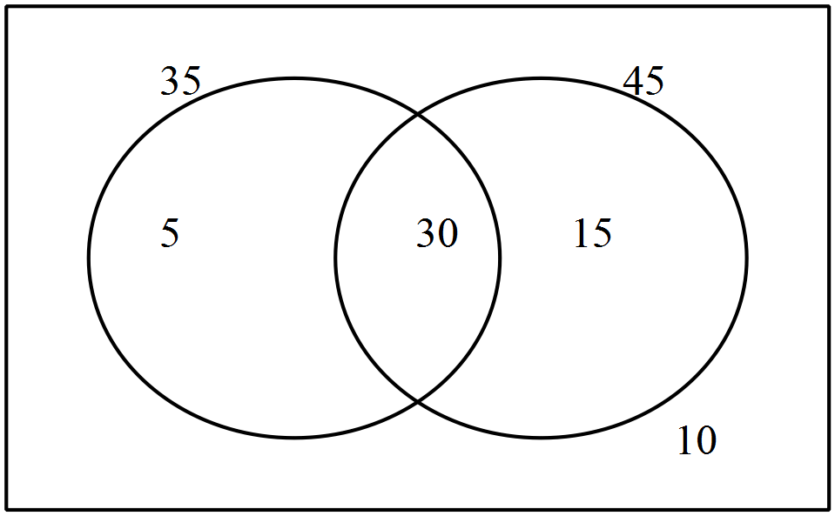

B

H

Find the probability that a selected student:

1. only studies History c) does not study History given they study Biology

5/60 or 1/12 ✓ 15/45 or 1/3✓

d) studies either Biology or History

50/60 or 5/6✓

1. [3 marks: 1, 2]

Shade the following Venn Diagrams according to the area indicated.

1. $A'∪B$ b) ✓✓

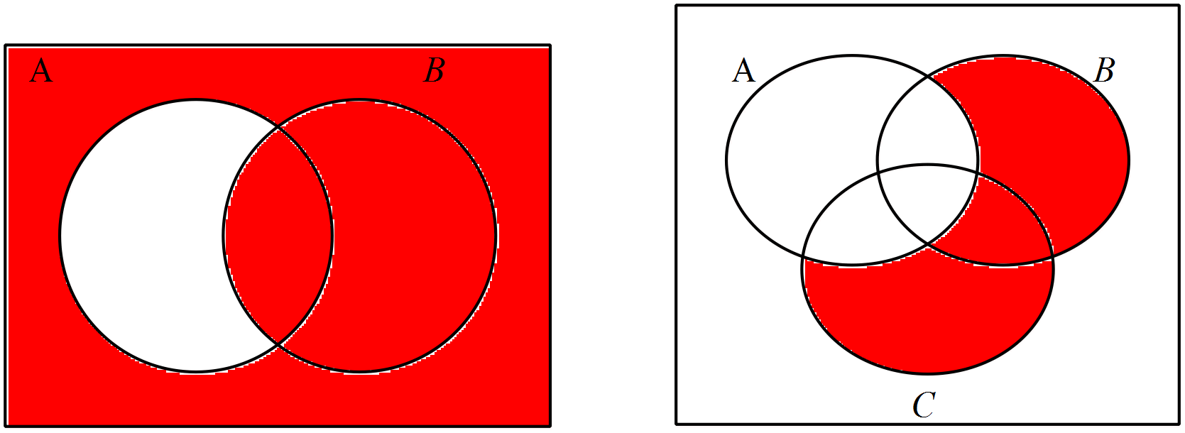

✓

1. [5 marks: 2, 2, 1]

Given that $P\left(\overline{A∪B}\right)=0.2 , P\left(B\right)=0.4$ and $P\left(A∩B\right)=0.2$;

1. Find $P\left(B | A\right).$ = 0.2/0.6 = 1/3✓✓
2. Determine with reasons if the events A and B are independent.

Not independent, ✓ P(B/A) is not equal to P(B), that is 1/3 is not equal to 0.4✓.

1. Determine with reasons if the events A and B are mutually exclusive.

Not mutually exclusive – the intersection of A and B is not = to 0. ✓

1. [5 marks: 2, 2, 1]
2. How many ways can I pick a team of 3 people from a group of 10
$$\text{1}\text{0}\text{C}\text{3 }\text{= }\frac{10!}{7!3!}\text{ =}\frac{10×9×8}{3×2×1}=120$$

3. How many 3-letter words with or without meaning, can be formed out of the letters of the word, 'LOGARITHMS', if repetition of letters is not allowed?

The word 'LOGARITHMS' has 10 different letters.  
  
Hence, the number of 3-letter words (with or without meaning) formed by using these letters  
= 10P3  
=10×9×8=720

1. A box contains 4 red, 3 white and 2 blue balls. Three balls are drawn at random. Find out the number of ways of selecting the balls of different colours?

1 red ball can be selected in 4C1 ways.  
1 white ball can be selected in 3C1 ways.  
1 blue ball can be selected in 2C1 ways.  
  
Total number of ways  
= 4C1 × 3C1 × 2C1  
= 4 × 3 × 2 = 24

1. **[2 marks: 2]**

Use Pascal’s Triangle to fully expand the expression .

1

1 1

1 2 1

1 3 3 1

1 4 6 4 1

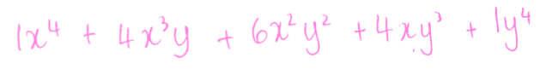

End of Part A

**Resource Rich Section**

TIME ALLOWED: 35 min Total marks: 34

1. [3 marks: 1, 1, 1]

A study of 211 people was done to determine whether gender was independent of chocolate bar consumption on a particular weekend . The results are shown in the table below. What is the probability that a person chosen at random was:

|  |  |  |  |
| --- | --- | --- | --- |
| No. of Choc Bars eaten | Male | Female | TOTAL |
| 0 | 45 | 33 | 78 |
| 1 | 38 | 21 | 59 |
| 2 | 25 | 18 | 43 |
| 3 | 14 | 9 | 23 |
| 4 | 6 | 2 | 8 |
| TOTAL | 128 | 83 | 211 |

a) a person that ate 2 or less chocolate bars? 180/211 or 0.85

b) a person that ate 2 or less chocolate bars given that they were male? 108/128 or 0.84

c) The study was expanded to include 2000 people. Estimate how many of those did not eat any chocolate bars, based on the table of data above.

78/211 *2000 = 739 people

8/ [4 marks: 1, 1, 2]

The probability of Alex achieving an A grade in Maths, Physics and Chemistry are 0.2, 0.3 and 0.9 respectively. If the grades are independent events determine the probability that Alex receives:

a) all A grades (0.2)(0.3)(0.9) = 0.54

b) no A grades (0.8)(0.7)(0.1) = 0.56

c) exactly 2 A grades (0.2)(0.3)(0.1) + (0.2)(0.9)(0.7)+(0.3)(0.9)(0.8) = 0.348

9 . [5 marks: 2, 1, 1, 1]

A bag contains 12 marbles; 5 red and 7 blue.

a) Draw a probability tree for taking 2 marbles from the bag without replacement.

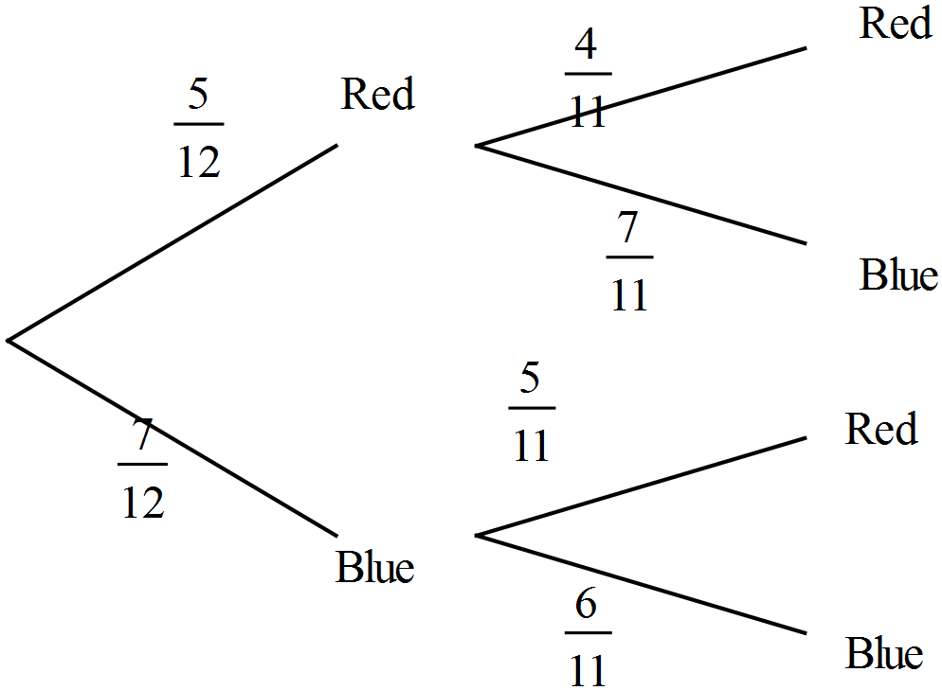

b) What is the probability of two reds? (5/12)(4/11) = 5/33

c) What is the probability that the two marbles are not the same colour?

(5/12)(7/11)+(7/12)(5/11) = 70/132 or 35/66

d) What is the probability that the two marbles are the same colour?

(5/12)(4/11) + (7/12)(6/11) = 62/132 or 31/66

|  |  |
| --- | --- |
| **10** | **[5 marks: 2, 2, 1]** |

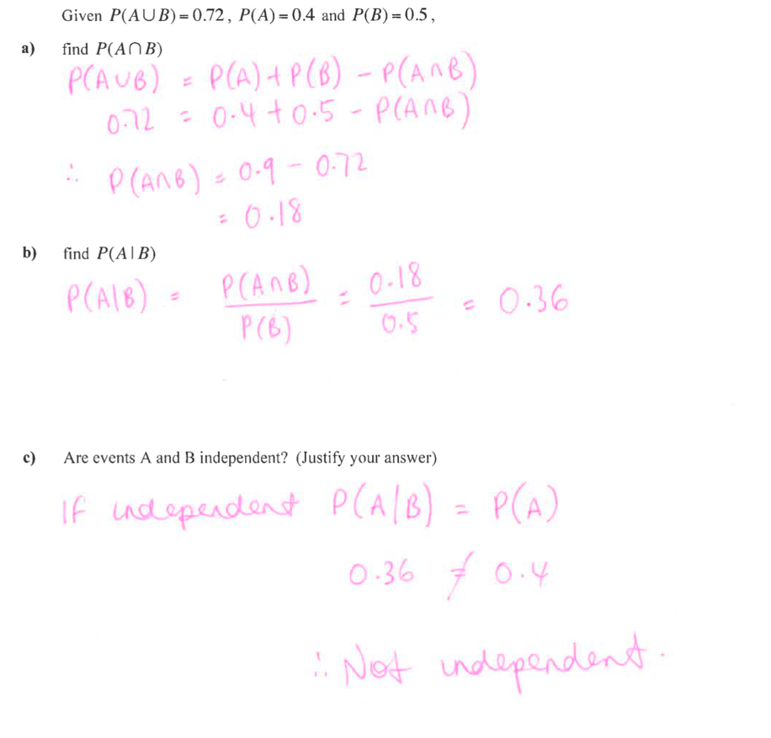

1. **[2 marks: 1, 1]**

Find the number of different four-digit numbers that can be formed from the digits 1, 2, 3, 4, 5, 6, 7, 8, 9, if each digit:

1. can only be used once

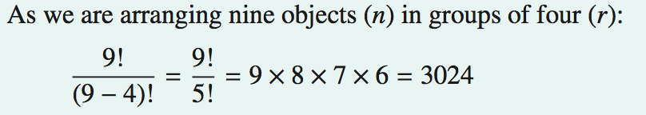

1. can be used more than once



**Question 12: [7 marks: 1, 2, 2, 2]**

